ASSIGNMENT 6
Vehicle Rental Management System
Unit: Object-Oriented Programming
Topic: Inheritance, Constructors & Access Modifiers
Assessment Type: Individual Coding Assignment

1. Objective
The objective of this assignment is to develop a Java-based Vehicle Rental Management System using object-oriented programming principles. The program uses a common Vehicle parent class and specialized Car, Bike, Scooter, and ElectricCar child classes. It demonstrates inheritance, constructors, encapsulation, access modifiers, method overriding, polymorphism, Scanner input, menu-driven programming, and rental charge calculation.

2. Problem Statement
Develop a system that allows a customer to rent different types of vehicles. Common information such as vehicle number, model, customer name, and rental days is stored in the parent Vehicle class. Each child class adds a unique property and implements its own rental calculation using its daily rate.

3. Vehicle Types and Rental Rates
Vehicle Type | Unique Property | Rate Per Day | Rental Formula
Car | Number of Seats | ₹1500 | Days × 1500
Bike | Engine Capacity | ₹700 | Days × 700
Scooter | Storage Capacity | ₹500 | Days × 500
Electric Car | Battery Capacity | ₹2000 | Days × 2000

4. Class Design and Inheritance
Vehicle is the parent class. It contains the common private data members vehicleNumber, vehicleModel, customerName, and rentalDays. Car, Bike, Scooter, and ElectricCar extend Vehicle using the extends keyword.
The child constructors call the parent constructor using super(...) and use the this keyword to initialize their own unique properties.

5. OOP Concepts Implemented
Concept | Implementation
Inheritance | Car, Bike, Scooter, and ElectricCar extend the Vehicle class.
Encapsulation | Common and child-specific fields are declared private.
Constructors | Constructors initialize inherited and unique properties.
this Keyword | Used to distinguish object fields from constructor parameters.
super Keyword | Used by child constructors to initialize the parent class.
Method Overriding | Child classes override displayDetails() and calculateRentalCharges().
Polymorphism | A Vehicle reference stores objects of different child classes.
Access Modifiers | Private fields and public methods demonstrate controlled access.
Scanner | User input is accepted through java.util.Scanner.

6. Menu Operations
1. Rent a Car
2. Rent a Bike
3. Rent a Scooter
4. Rent an Electric Car
5. Display Rental Details
6. Calculate Rental Charges
7. Exit

7. Rental Calculation
Rental Charges = Rental Days × Rate Per Day
In the demonstrated execution, a Bike with vehicle number 106 and model Shotgun 650 was rented to Sasanka for 5 days. The rate was ₹700 per day.
Calculation: 5 × ₹700 = ₹3500

8. Complete Source Code
import java.util.Scanner;

class Vehicle {
private String vehicleNumber;
private String vehicleModel;
private String customerName;
private int rentalDays;

Vehicle(String vehicleNumber, String vehicleModel,
String customerName, int rentalDays) {
this.vehicleNumber = vehicleNumber;
this.vehicleModel = vehicleModel;
this.customerName = customerName;
this.rentalDays = rentalDays;
}

public String getVehicleNumber() { return vehicleNumber; }
public String getVehicleModel() { return vehicleModel; }
public String getCustomerName() { return customerName; }
public int getRentalDays() { return rentalDays; }

public void displayDetails() {
System.out.println("Vehicle Number : " + vehicleNumber);
System.out.println("Model : " + vehicleModel);
System.out.println("Customer Name : " + customerName);
System.out.println("Rental Days : " + rentalDays);
}

public double calculateRentalCharges() {
return 0;
}
}

class Car extends Vehicle {
private int numberOfSeats;

Car(String vehicleNumber, String vehicleModel,
String customerName, int rentalDays, int numberOfSeats) {
super(vehicleNumber, vehicleModel, customerName, rentalDays);
this.numberOfSeats = numberOfSeats;
}

@Override
public void displayDetails() {
System.out.println("Vehicle Type : Car");
super.displayDetails();
System.out.println("Number of Seats: " + numberOfSeats);
System.out.println("Rate Per Day : ₹1500");
}

@Override
public double calculateRentalCharges() {
return getRentalDays() * 1500;
}
}

class Bike extends Vehicle {
private int engineCapacity;

Bike(String vehicleNumber, String vehicleModel,
String customerName, int rentalDays, int engineCapacity) {
super(vehicleNumber, vehicleModel, customerName, rentalDays);
this.engineCapacity = engineCapacity;
}

@Override
public void displayDetails() {
System.out.println("Vehicle Type : Bike");
super.displayDetails();
System.out.println("Engine Capacity: " + engineCapacity + " cc");
System.out.println("Rate Per Day : ₹700");
}

@Override
public double calculateRentalCharges() {
return getRentalDays() * 700;
}
}

class Scooter extends Vehicle {
private int storageCapacity;

Scooter(String vehicleNumber, String vehicleModel,
String customerName, int rentalDays, int storageCapacity) {
super(vehicleNumber, vehicleModel, customerName, rentalDays);
this.storageCapacity = storageCapacity;
}

@Override
public void displayDetails() {
System.out.println("Vehicle Type : Scooter");
super.displayDetails();
System.out.println("Storage Capacity: " + storageCapacity + " litres");
System.out.println("Rate Per Day : ₹500");
}

@Override
public double calculateRentalCharges() {
return getRentalDays() * 500;
}
}

class ElectricCar extends Vehicle {
private double batteryCapacity;

ElectricCar(String vehicleNumber, String vehicleModel,
String customerName, int rentalDays,
double batteryCapacity) {
super(vehicleNumber, vehicleModel, customerName, rentalDays);
this.batteryCapacity = batteryCapacity;
}

@Override
public void displayDetails() {
System.out.println("Vehicle Type : Electric Car");
super.displayDetails();
System.out.println("Battery Capacity: " + batteryCapacity + " kWh");
System.out.println("Rate Per Day : ₹2000");
}

@Override
public double calculateRentalCharges() {
return getRentalDays() * 2000;
}
}

public class VehicleRentalManagementSystem {
public static void main(String[] args) {
Scanner scanner = new Scanner(System.in);
Vehicle rentedVehicle = null;
int choice;

do {
System.out.println("\n================================");
System.out.println(" VEHICLE RENTAL SYSTEM");
System.out.println("================================");
System.out.println("1. Rent a Car");
System.out.println("2. Rent a Bike");
System.out.println("3. Rent a Scooter");
System.out.println("4. Rent an Electric Car");
System.out.println("5. Display Rental Details");
System.out.println("6. Calculate Rental Charges");
System.out.println("7. Exit");
System.out.println("================================");
System.out.print("Enter your choice: ");

choice = scanner.nextInt();
scanner.nextLine();

switch (choice) {
case 1:
System.out.println("\n--- Rent a Car ---");
System.out.print("Enter Vehicle Number: ");
String carNumber = scanner.nextLine();
System.out.print("Enter Vehicle Model: ");
String carModel = scanner.nextLine();
System.out.print("Enter Customer Name: ");
String carCustomer = scanner.nextLine();
System.out.print("Enter Rental Days: ");
int carDays = scanner.nextInt();
System.out.print("Enter Number of Seats: ");
int seats = scanner.nextInt();

rentedVehicle = new Car(carNumber, carModel,
carCustomer, carDays, seats);
System.out.println("\nVehicle rented successfully!");
break;

case 2:
System.out.println("\n--- Rent a Bike ---");
System.out.print("Enter Vehicle Number: ");
String bikeNumber = scanner.nextLine();
System.out.print("Enter Vehicle Model: ");
String bikeModel = scanner.nextLine();
System.out.print("Enter Customer Name: ");
String bikeCustomer = scanner.nextLine();
System.out.print("Enter Rental Days: ");
int bikeDays = scanner.nextInt();
System.out.print("Enter Engine Capacity (cc): ");
int engineCapacity = scanner.nextInt();

rentedVehicle = new Bike(bikeNumber, bikeModel,
bikeCustomer, bikeDays, engineCapacity);
System.out.println("\nVehicle rented successfully!");
break;

case 3:
System.out.println("\n--- Rent a Scooter ---");
System.out.print("Enter Vehicle Number: ");
String scooterNumber = scanner.nextLine();
System.out.print("Enter Vehicle Model: ");
String scooterModel = scanner.nextLine();
System.out.print("Enter Customer Name: ");
String scooterCustomer = scanner.nextLine();
System.out.print("Enter Rental Days: ");
int scooterDays = scanner.nextInt();
System.out.print("Enter Storage Capacity (litres): ");
int storageCapacity = scanner.nextInt();

rentedVehicle = new Scooter(scooterNumber, scooterModel,
scooterCustomer, scooterDays, storageCapacity);
System.out.println("\nVehicle rented successfully!");
break;

case 4:
System.out.println("\n--- Rent an Electric Car ---");
System.out.print("Enter Vehicle Number: ");
String electricNumber = scanner.nextLine();
System.out.print("Enter Vehicle Model: ");
String electricModel = scanner.nextLine();
System.out.print("Enter Customer Name: ");
String electricCustomer = scanner.nextLine();
System.out.print("Enter Rental Days: ");
int electricDays = scanner.nextInt();
System.out.print("Enter Battery Capacity (kWh): ");
double batteryCapacity = scanner.nextDouble();

rentedVehicle = new ElectricCar(electricNumber, electricModel,
electricCustomer, electricDays, batteryCapacity);
System.out.println("\nElectric car rented successfully!");
break;

case 5:
System.out.println("\n===== VEHICLE RENTAL DETAILS =====");
if (rentedVehicle != null)
rentedVehicle.displayDetails();
else
System.out.println("No vehicle has been rented yet.");
break;

case 6:
System.out.println("\n===== VEHICLE RENTAL RECEIPT =====");
if (rentedVehicle != null) {
rentedVehicle.displayDetails();
double totalAmount =
rentedVehicle.calculateRentalCharges();
System.out.println("--------------------------------");
System.out.println("Total Amount : ₹" + totalAmount);
System.out.println("--------------------------------");
} else {
System.out.println("No vehicle has been rented yet.");
}
break;

case 7:
System.out.println("\nThank you for using");
System.out.println("Vehicle Rental Management System!");
break;

default:
System.out.println("\nInvalid choice. Please try again.");
}
} while (choice != 7);

scanner.close();
}
}

9. Execution Screenshots
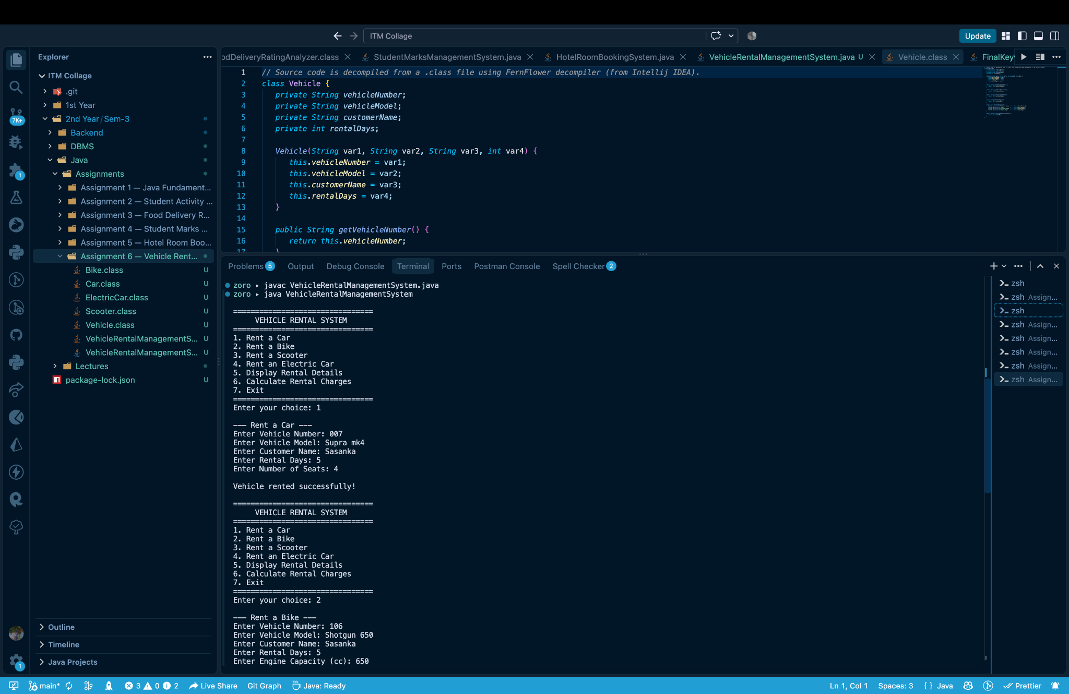
Figure 1: Vehicle Rental System menu and Car rental input.
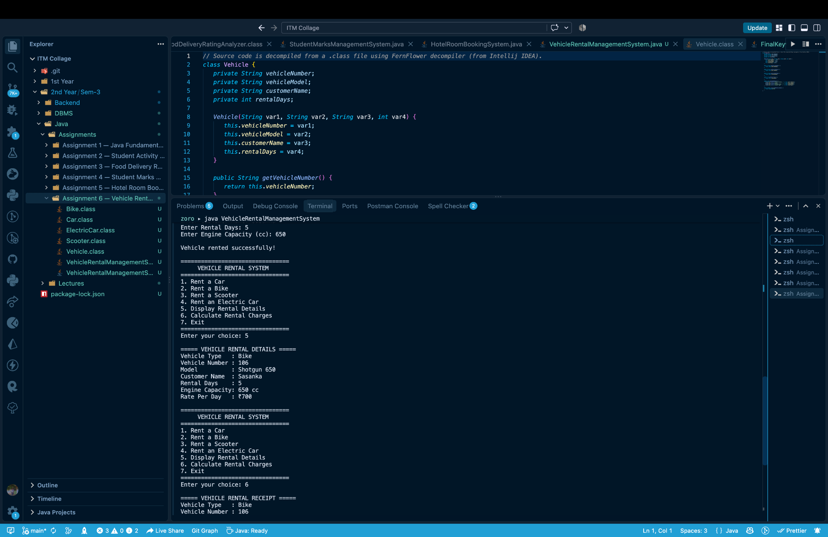
Figure 2: Bike rental details displayed after successful rental.
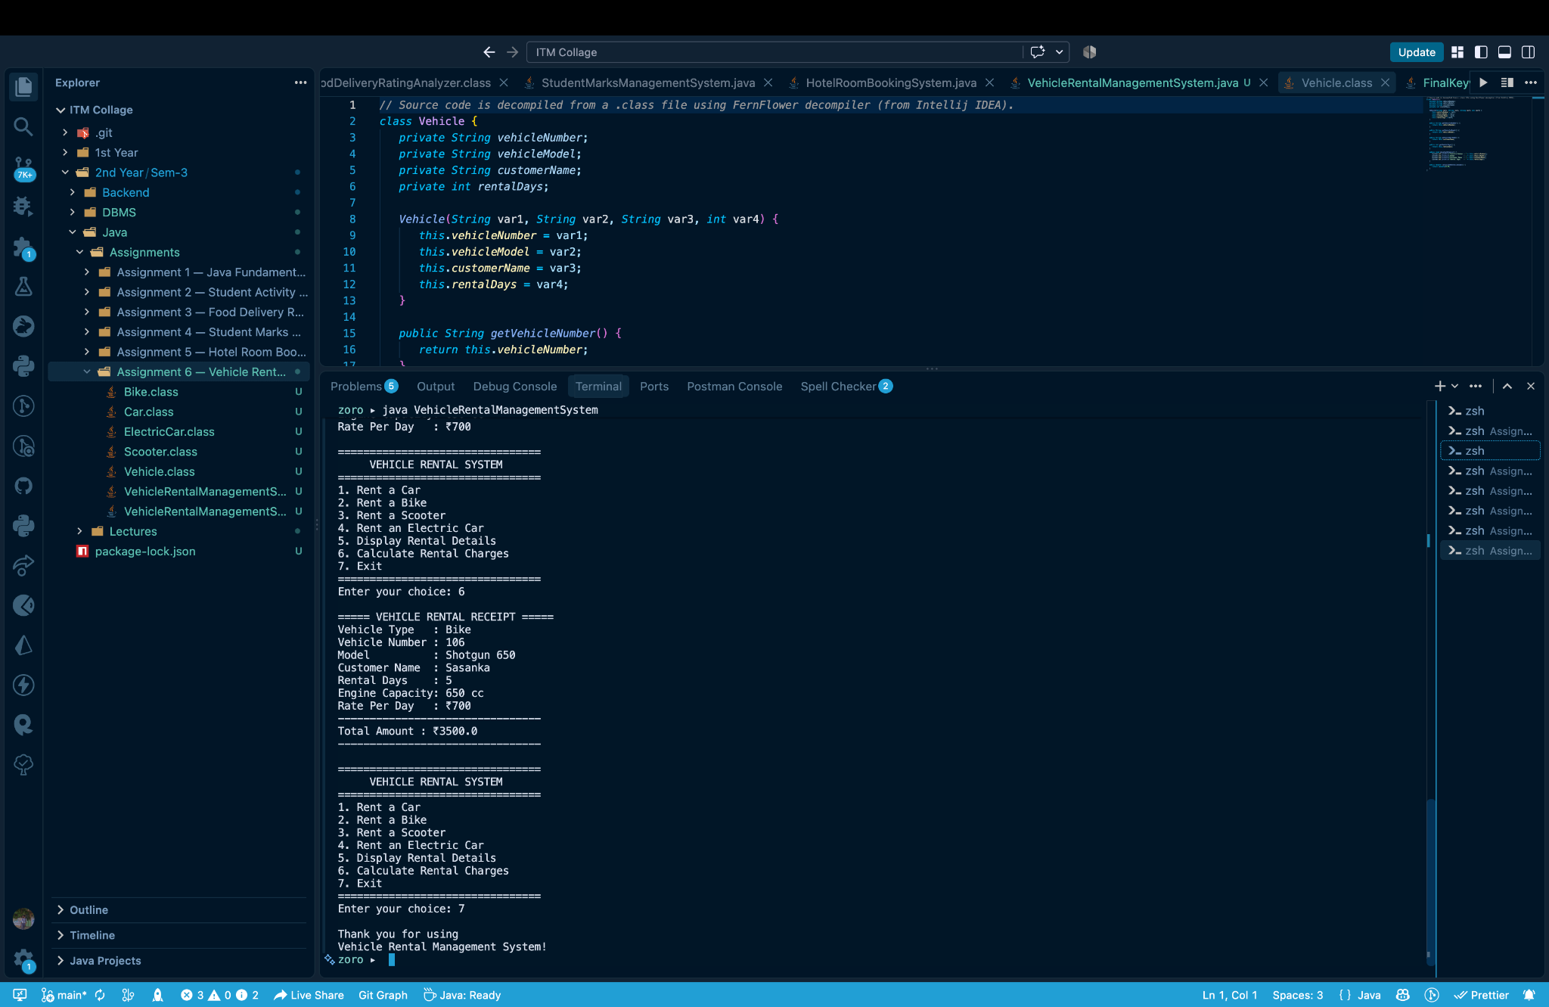
Figure 3: Rental receipt showing Bike charge calculation and program exit.

10. Result
The Vehicle Rental Management System was successfully implemented and executed. The program accepts vehicle and customer information, stores the selected vehicle through a parent-class reference, displays rental details, and calculates the correct rental amount according to the vehicle type. The demonstrated Bike rental for 5 days produced a total charge of ₹3500.

11. Requirement Verification
✓ Parent Vehicle class created.
✓ Car, Bike, and Scooter created using inheritance.
✓ ElectricCar added as the additional vehicle type.
✓ Common properties defined in Vehicle.
✓ Unique property added to every child class.
✓ Constructors used for object initialization.
✓ this keyword used in constructors.
✓ Private data members used for encapsulation.
✓ Methods created for displaying details and calculating charges.
✓ Scanner used for user input.
✓ Menu-driven loop implemented.
✓ Rental charges correctly calculated using days × daily rate.

12. Conclusion
This assignment demonstrates how inheritance can reduce code duplication by placing common vehicle information and behaviour in a parent class. The child classes extend the parent with specialized properties and rental calculations. Constructors, access modifiers, this, super, method overriding, and polymorphism are combined to create a clear and reusable Vehicle Rental Management System.

